**Scenario** : Our security team is asking for help ensuring proper reviews are being done to code being added into our repositories. We have hundreds of repositories in our organization. What is the best way we can achieve at scale?

A**nalysis of customer request :**   
Note : Security Team represent a Customer

Before starting any implementation/resolution I will be performing some analysis which are part of the SDLC methodologies to better assist the security team.

A- Security team ( internal our organization)

B- Ensuring proper reviews are being done to code added into repositories ( it means use any github tools or functionality to make sure we have Pull request that has been enforced)

C- hundreds of repositories in our organization ( enforcing code review on multiple repositories .

D- We are new to some of the out-of-the-box settings and the GitHub API ( create a step by step resolution to support the customer)

I will be created a step by step POC ( proof of concept) of the entire steps which will have a double effects :

1- Resolve the customer issue

2- Educate the Customer which will immediately break any key cycle dependency. It will be good to setup code review , if it hasn’t been done on the repo.

**Solution/use case:**

A- We will use Reviewable which is a code review tool for GitHub pull requests. It is free for open source repositories but not for enterprise Github accounts.  
Go to : <https://reviewable.io/>  
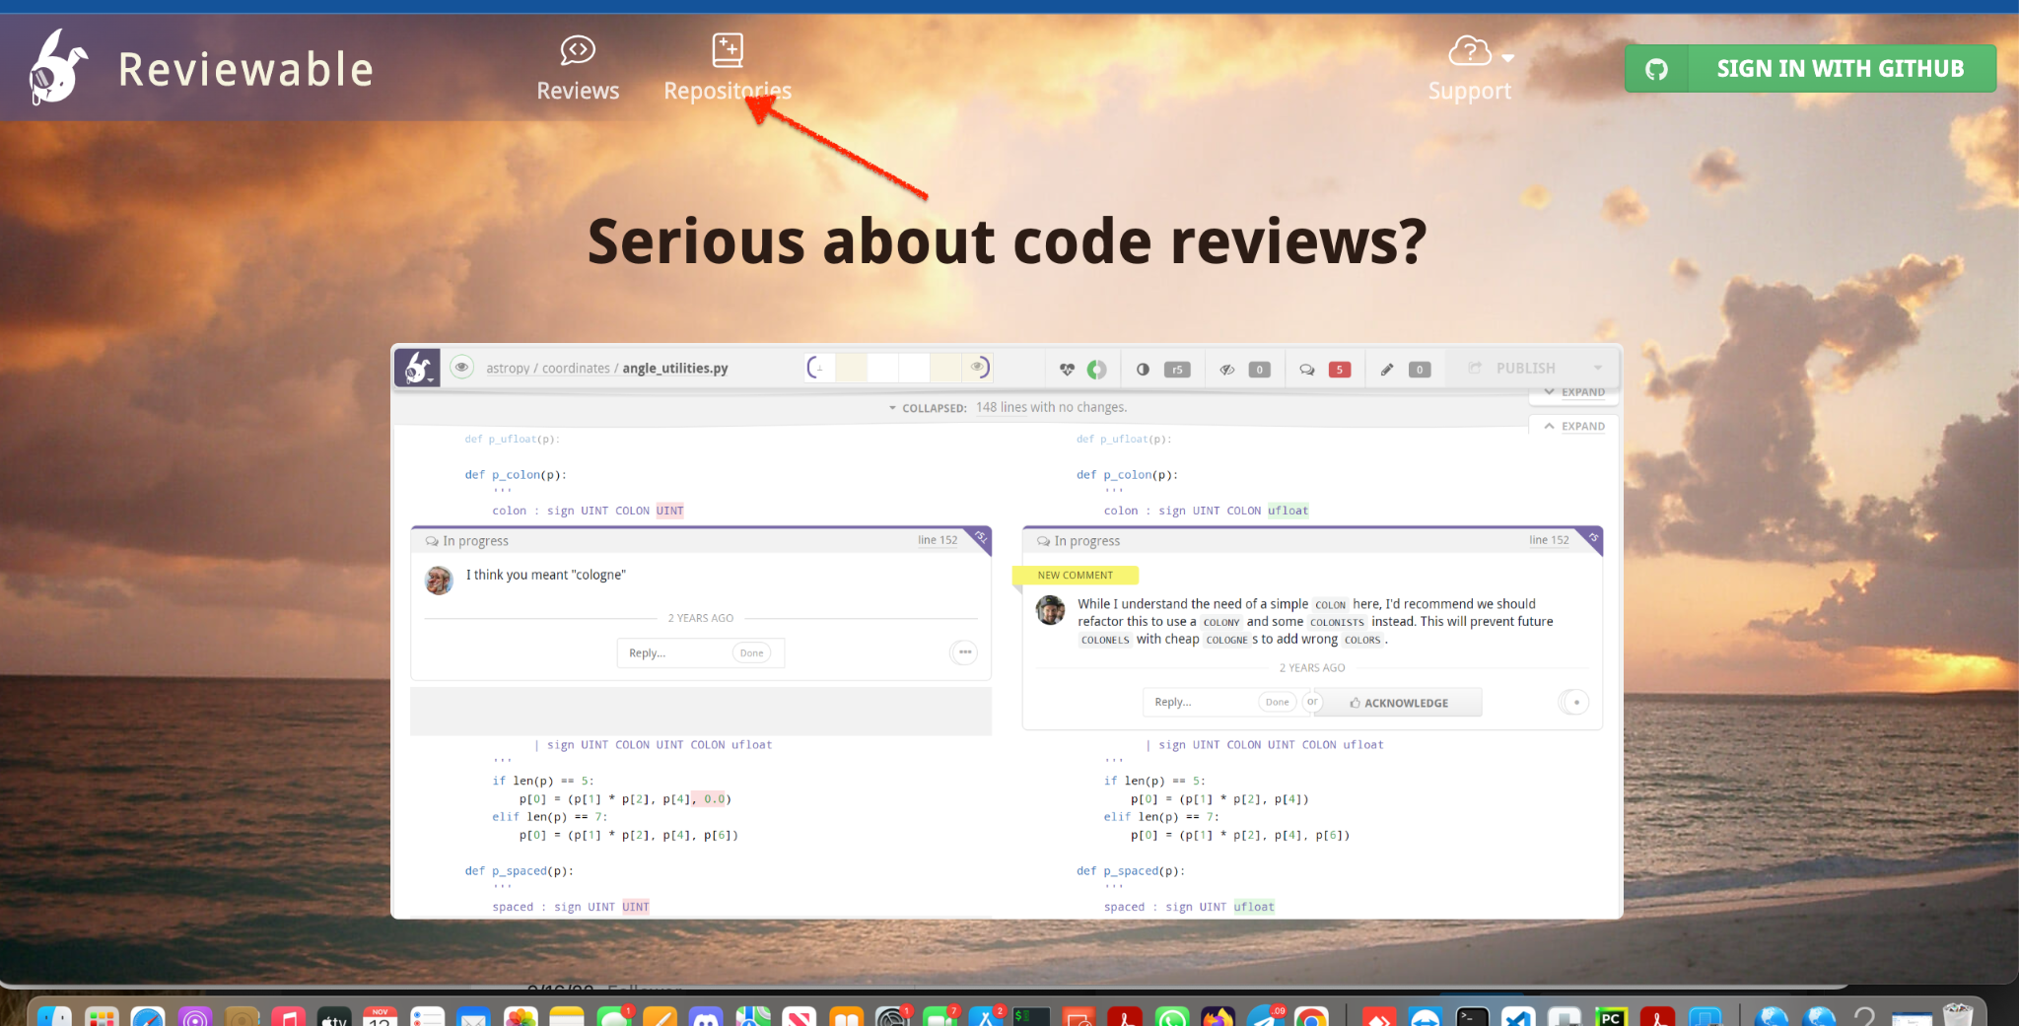

B- Click on Repositories   
At this step we will synchronize github with **reviewable** and authorize **reviewable to access github.**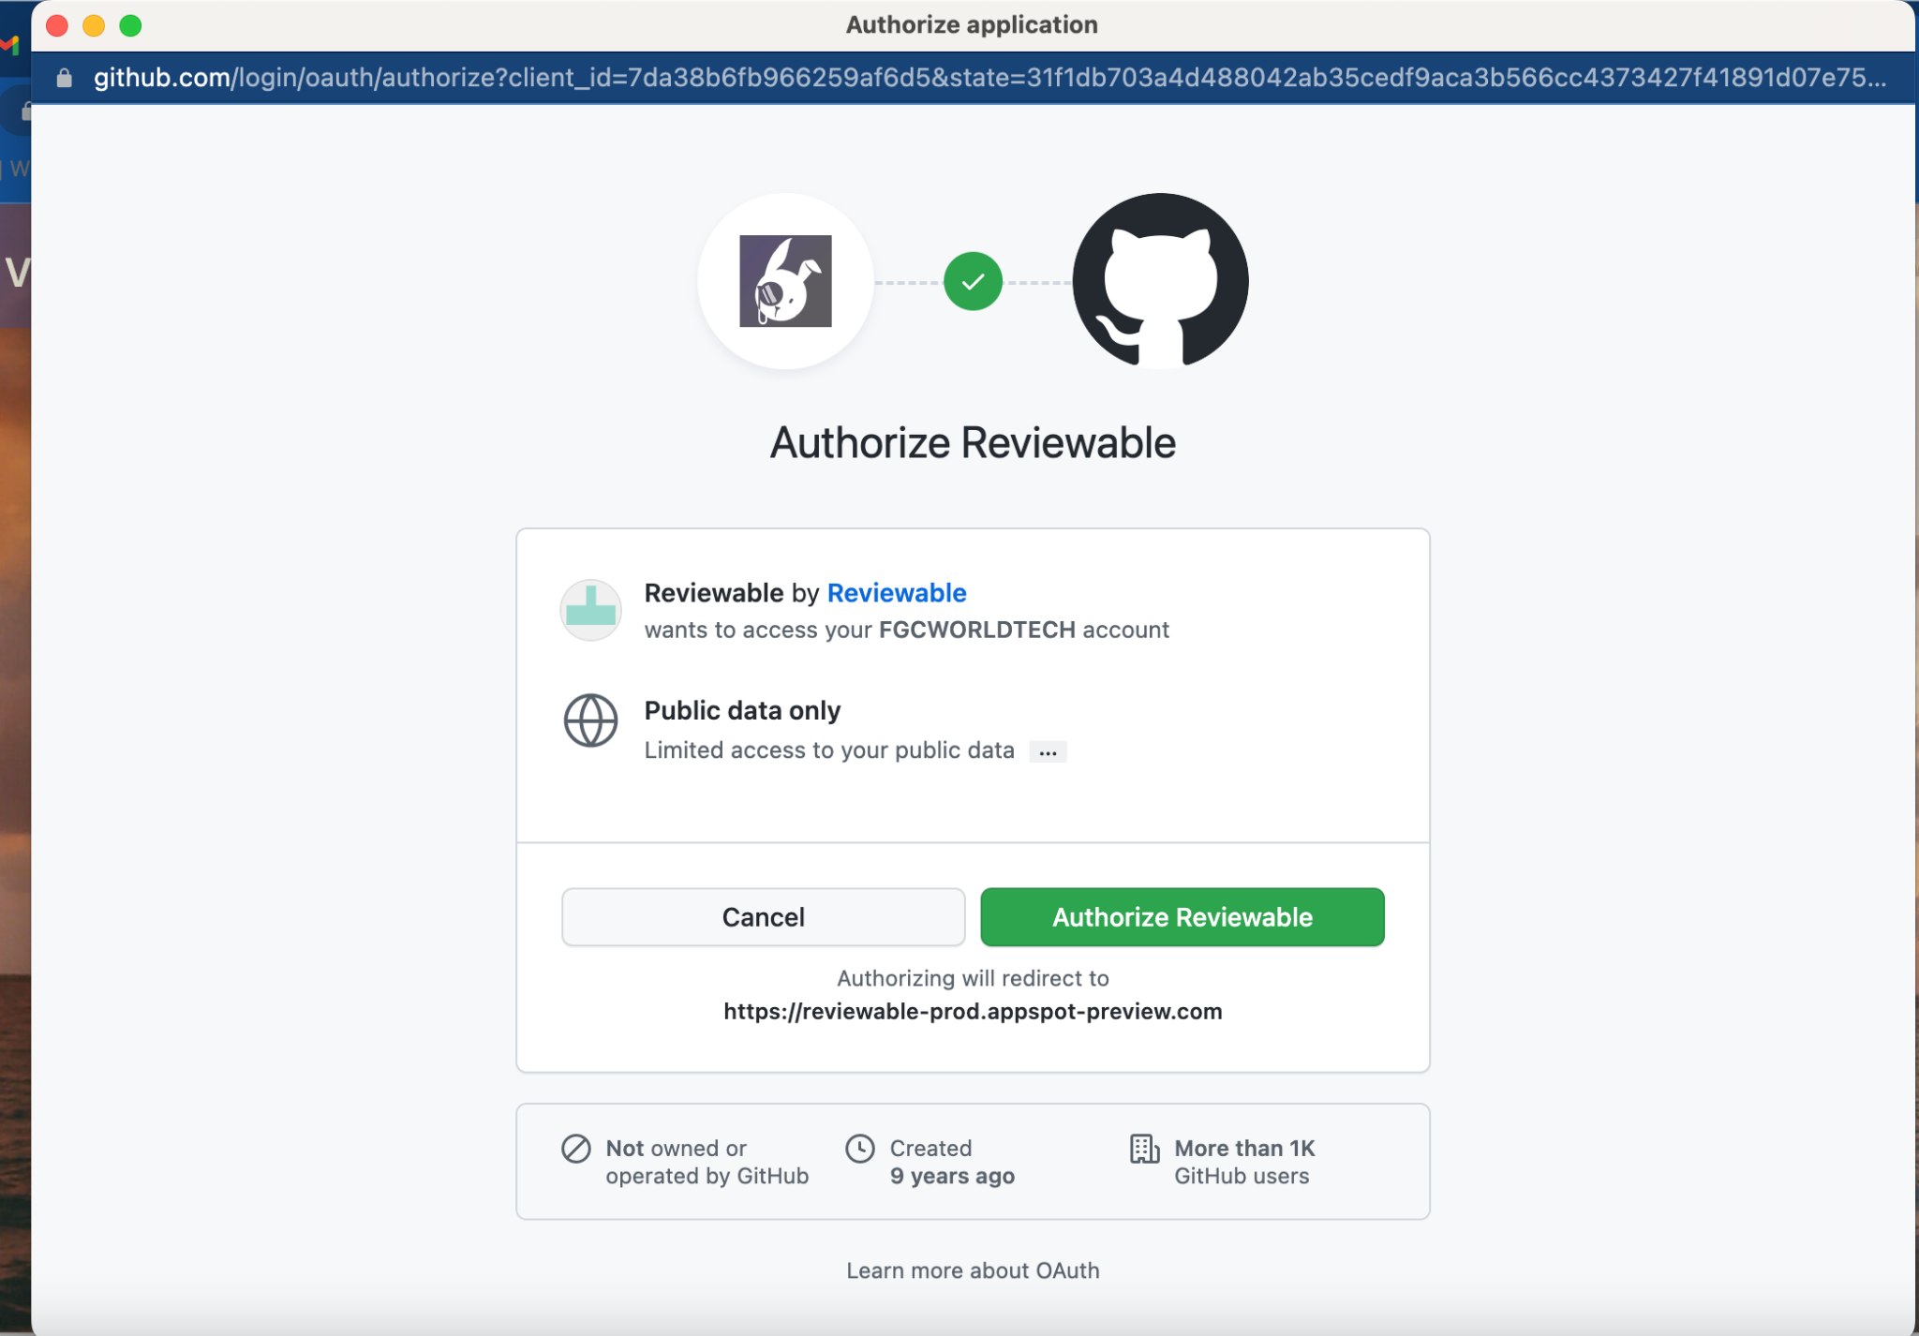

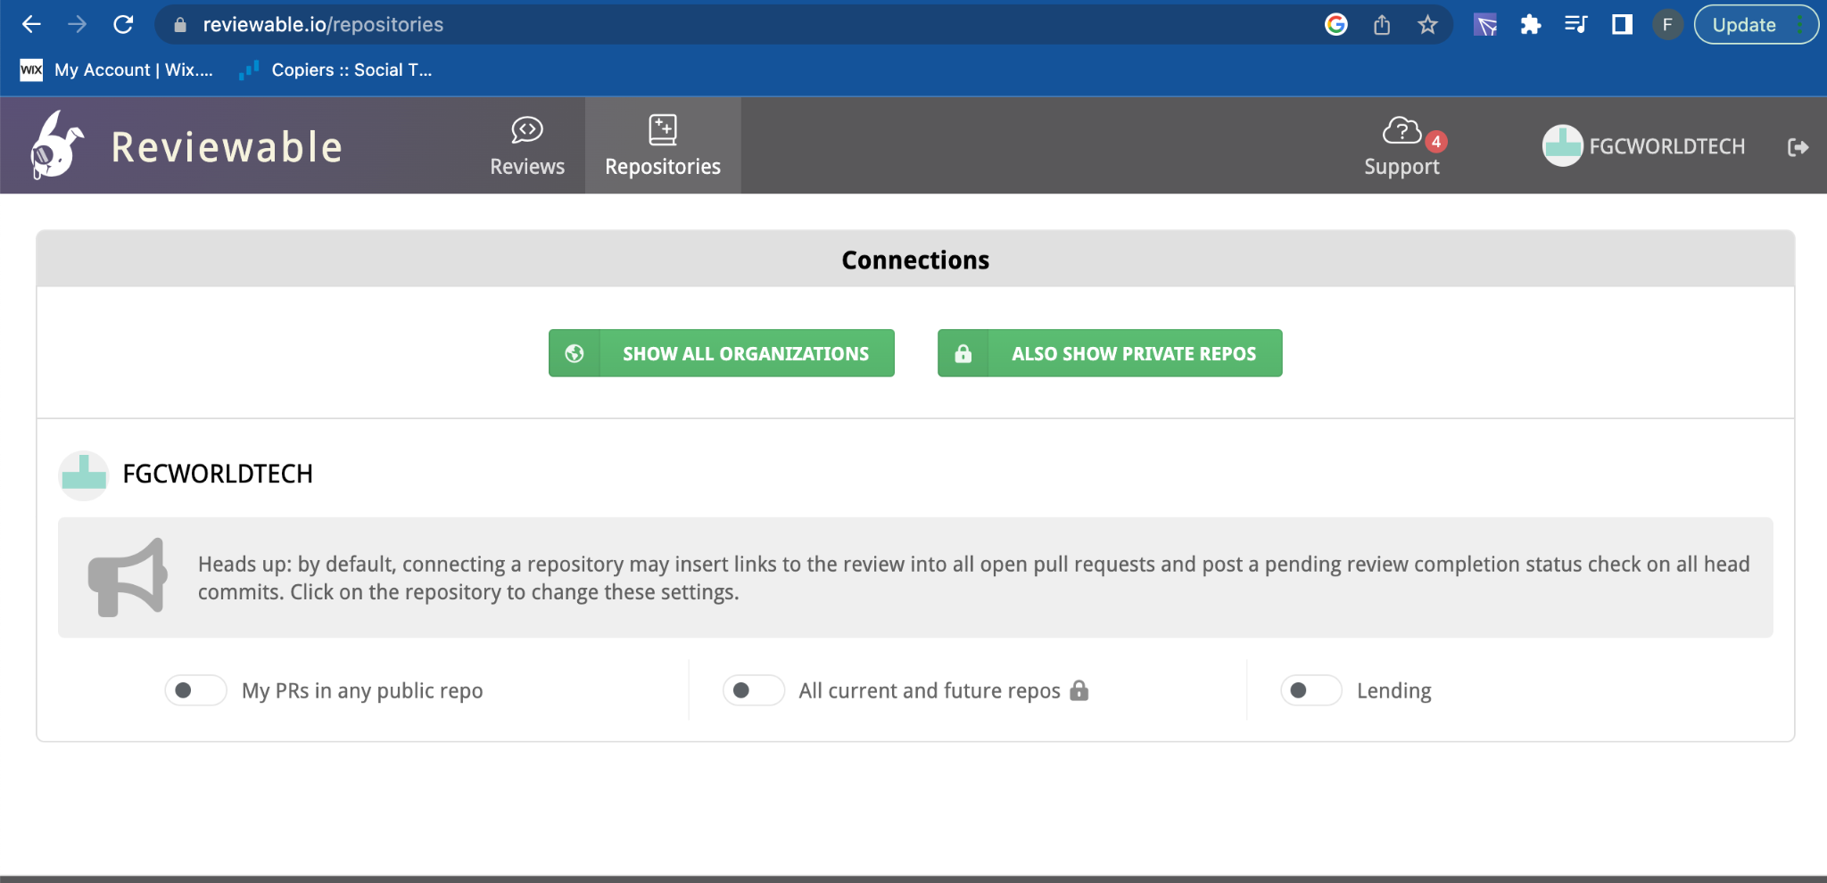

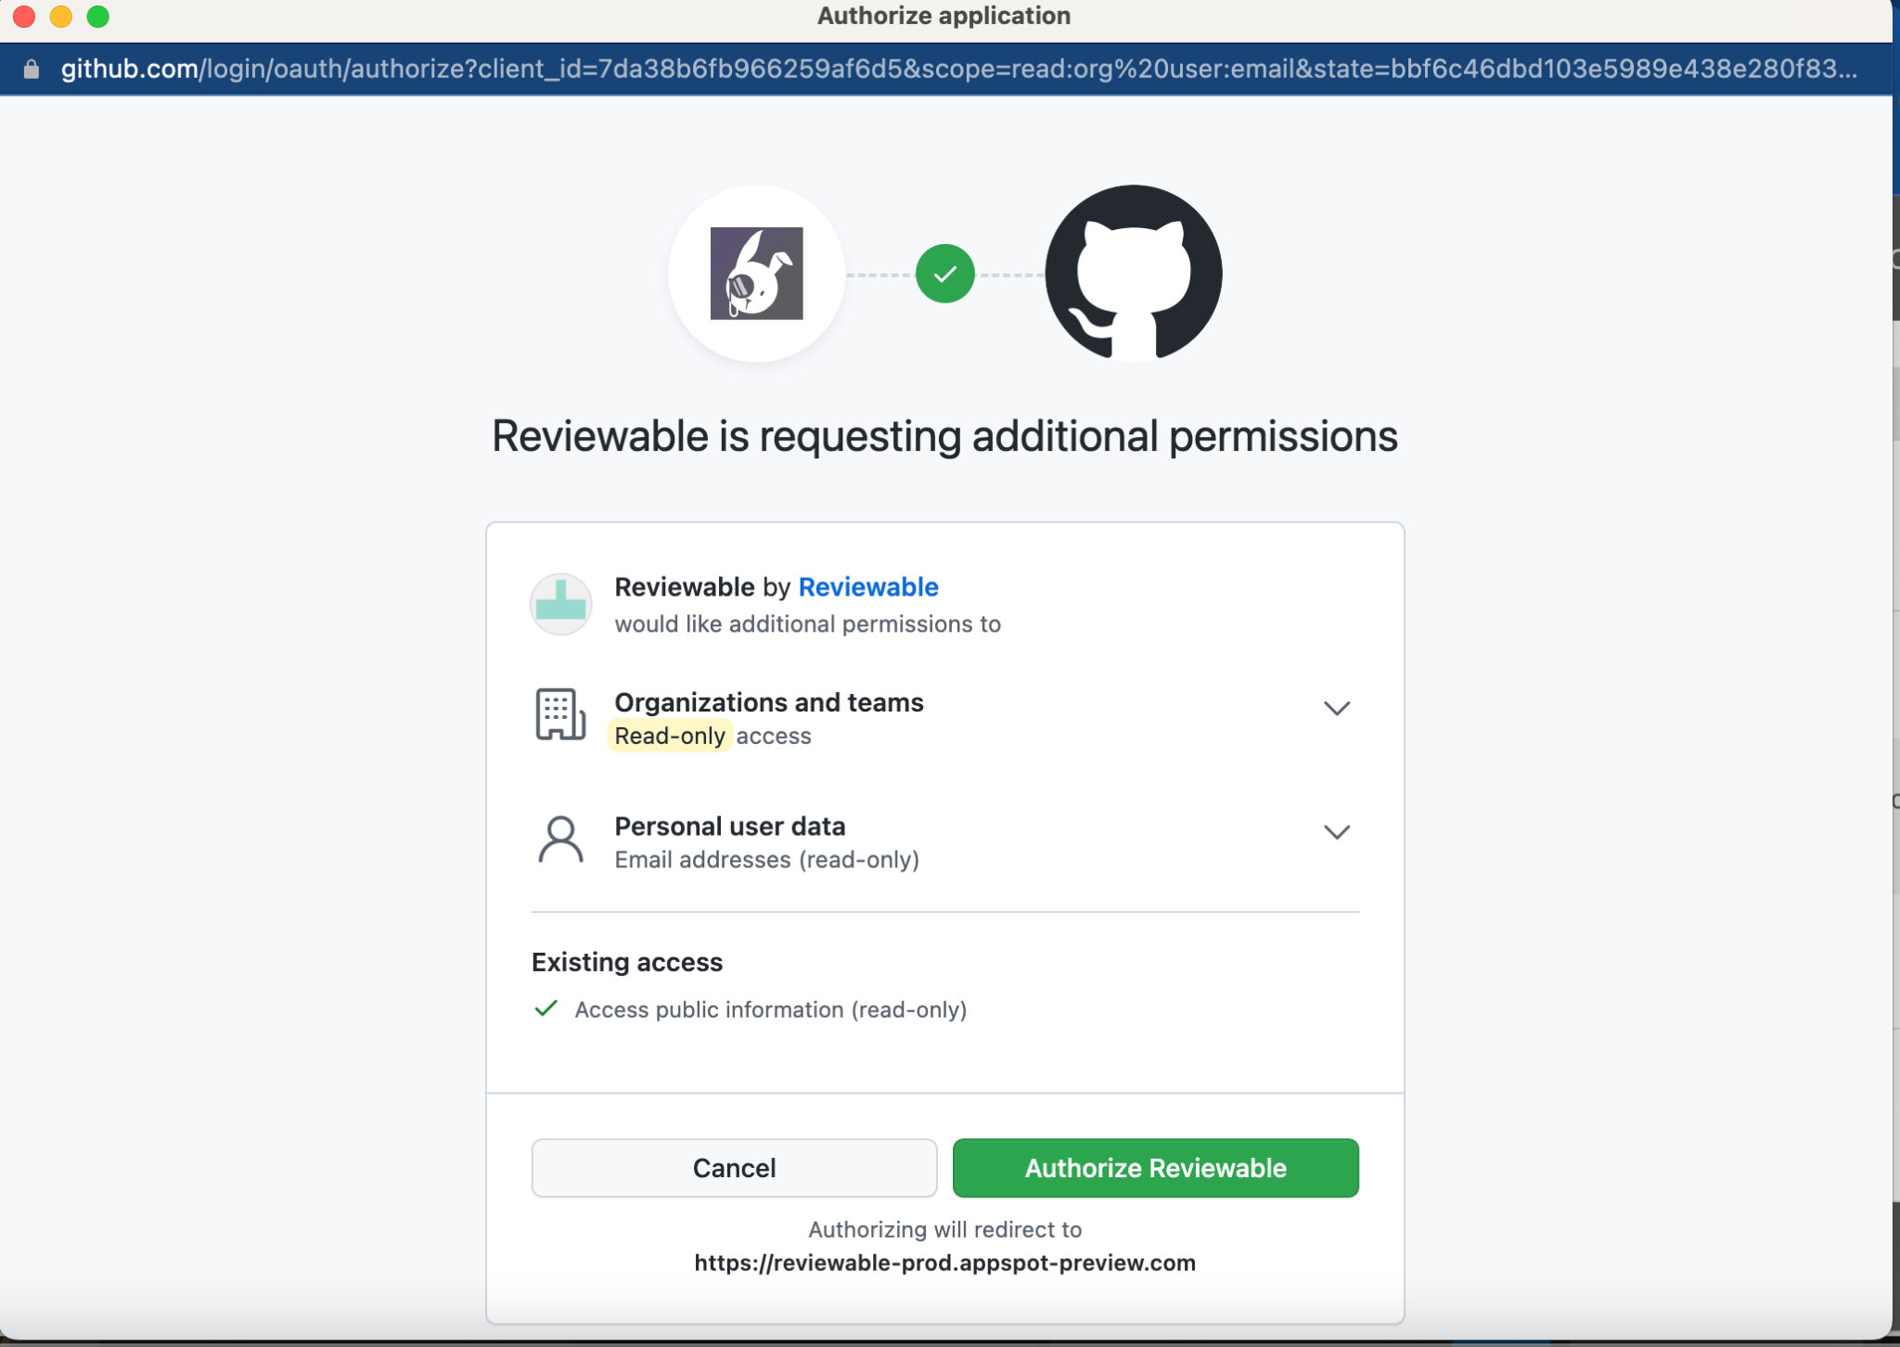

Click on repositories and enable the connections   


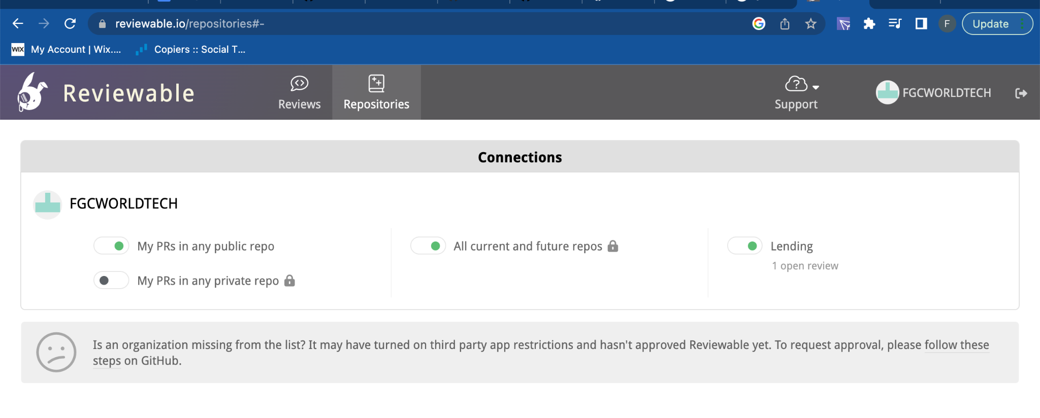

Finally, run a Pull request to test the tool. If no existing commit ahead from the feature branch to perform, please check the PR creation section below (part 4)

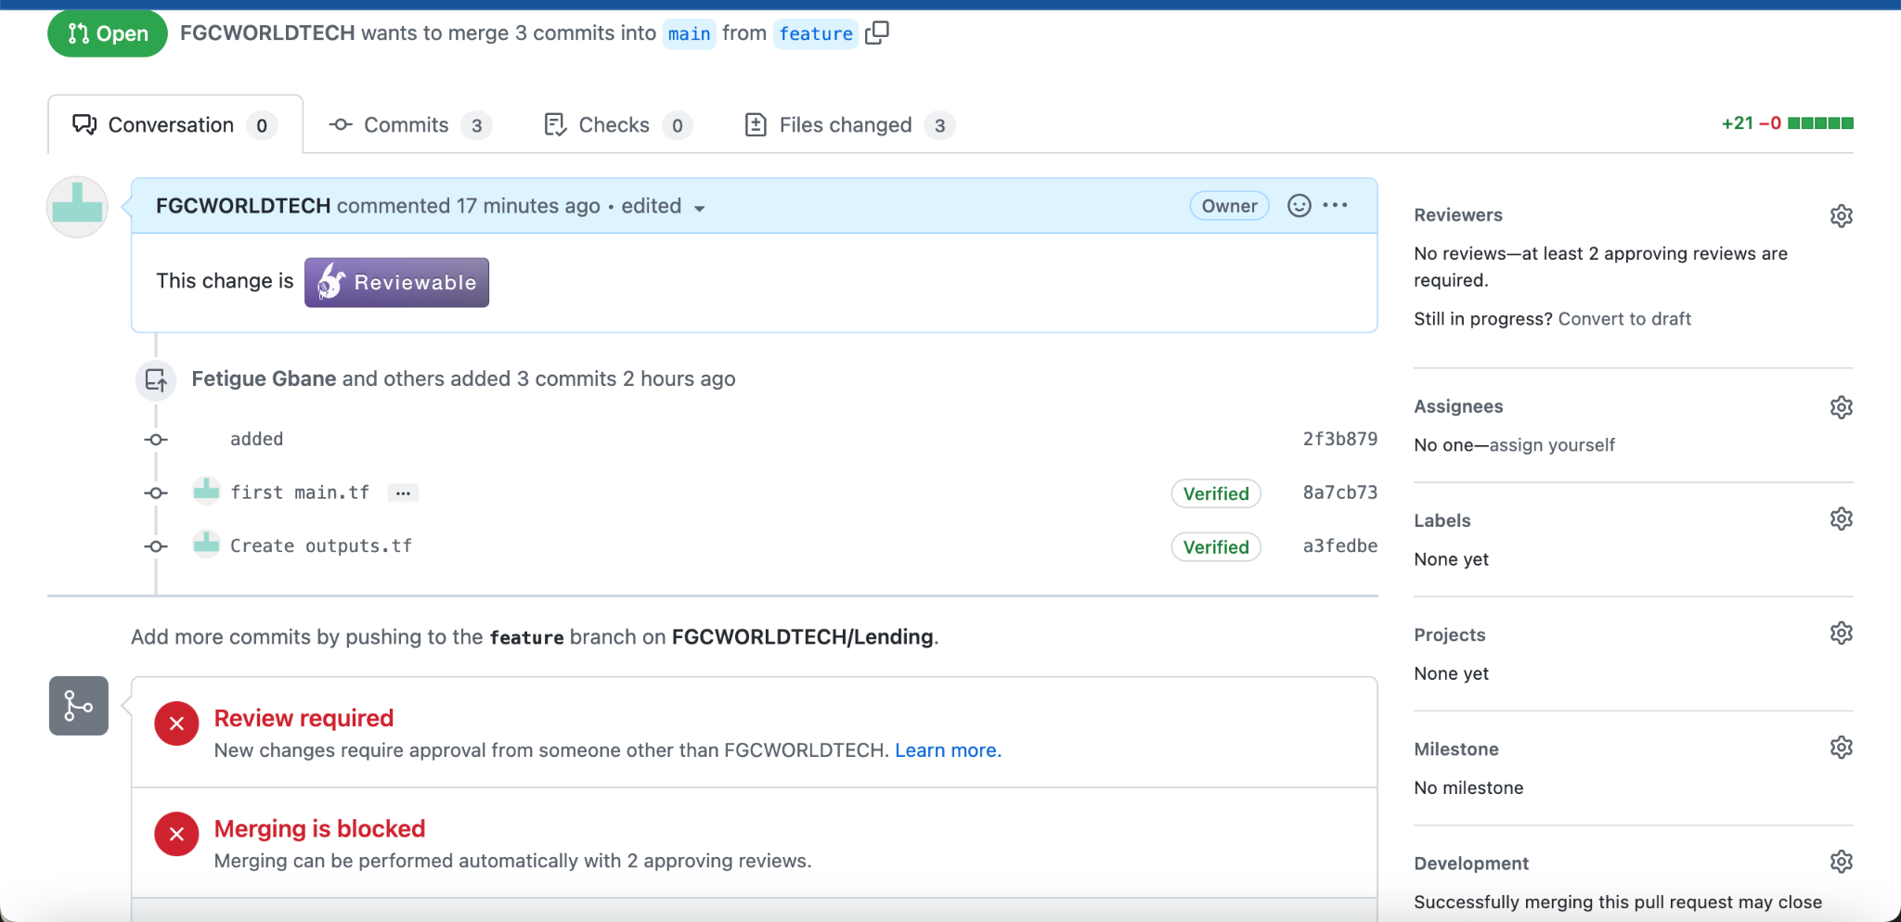

Now the below steps are additional steps to be performed if the customer would like to setup code reviews

1- Create a Github repository if you don’t have any . In this case I will make it public.  
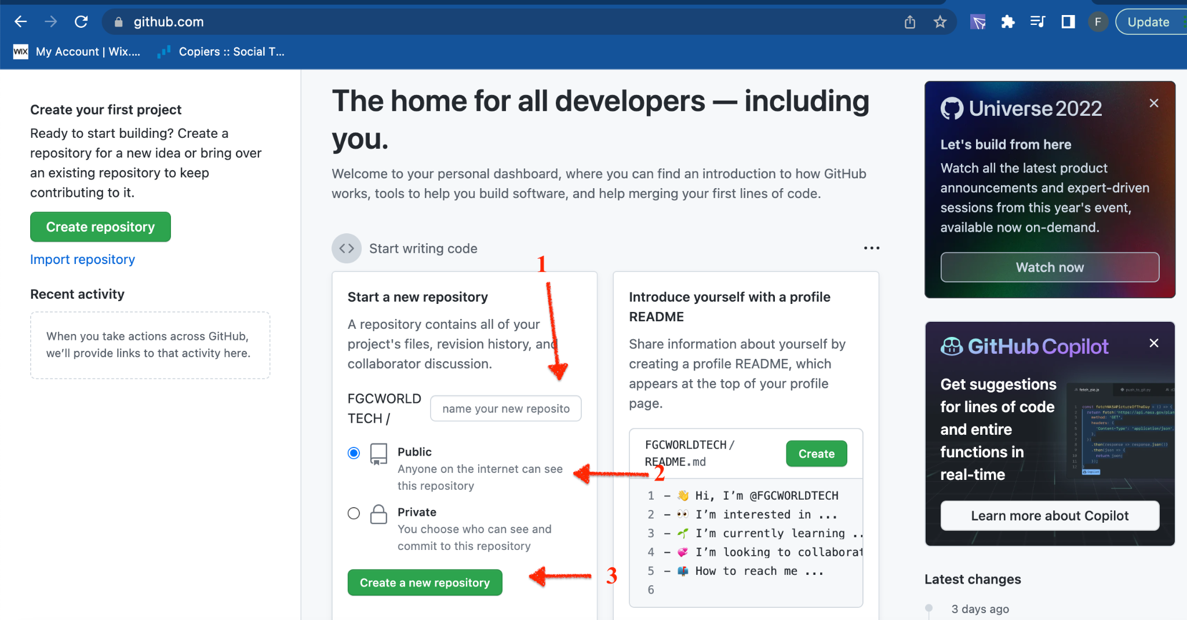

2- Now, we will need to clone a repository to our local ( personal) computer to do

2-1- Create A personal Token

* Click on click at the org level   
  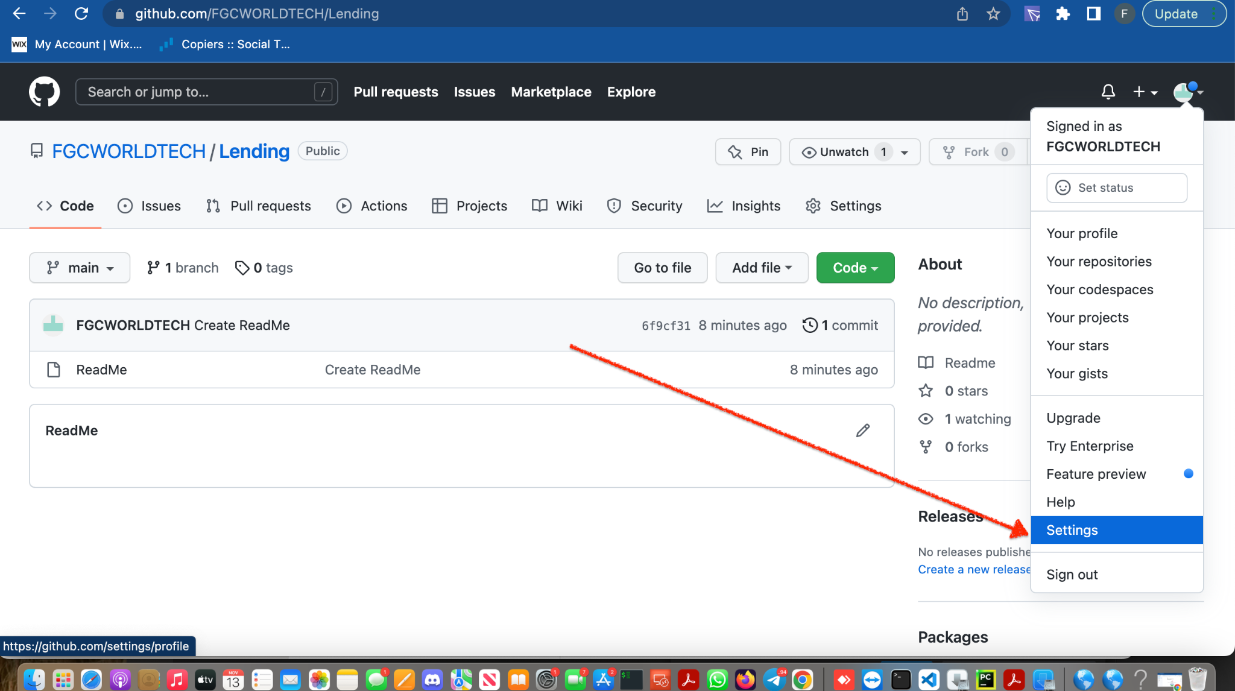
* Click on Personal access tokens and then Tokens (classic)

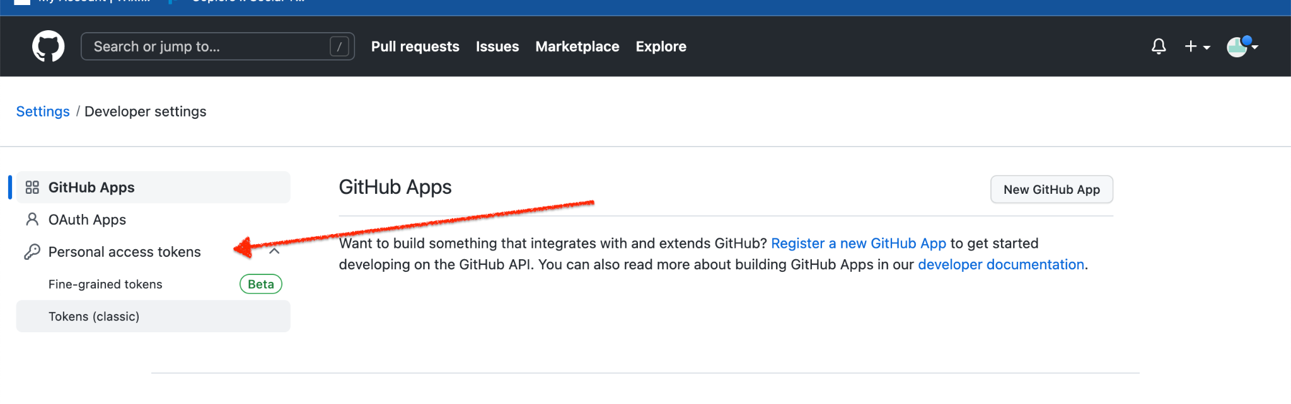

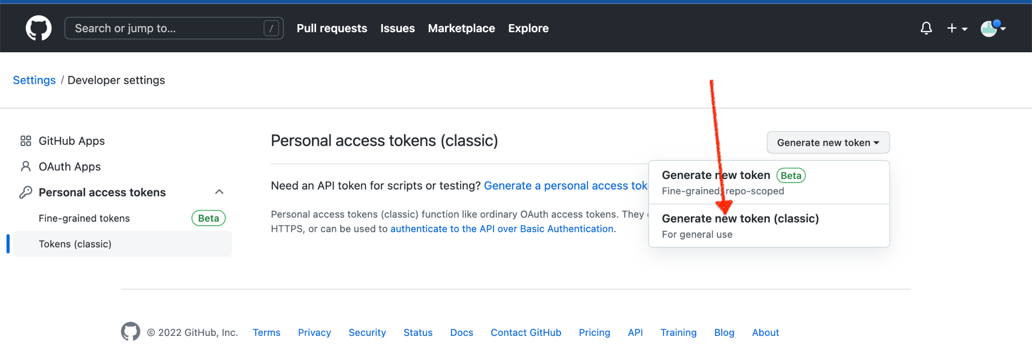

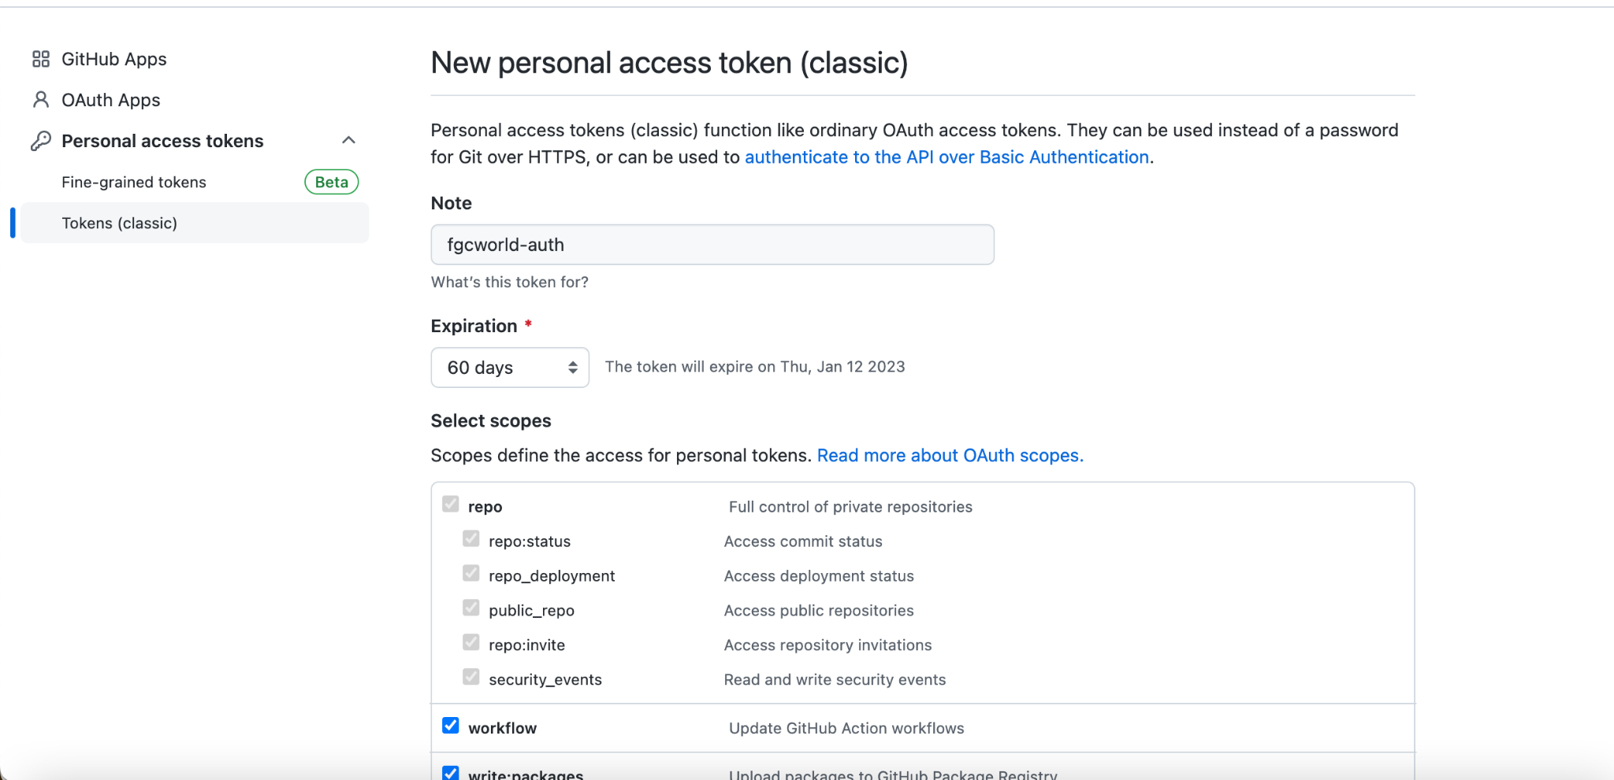

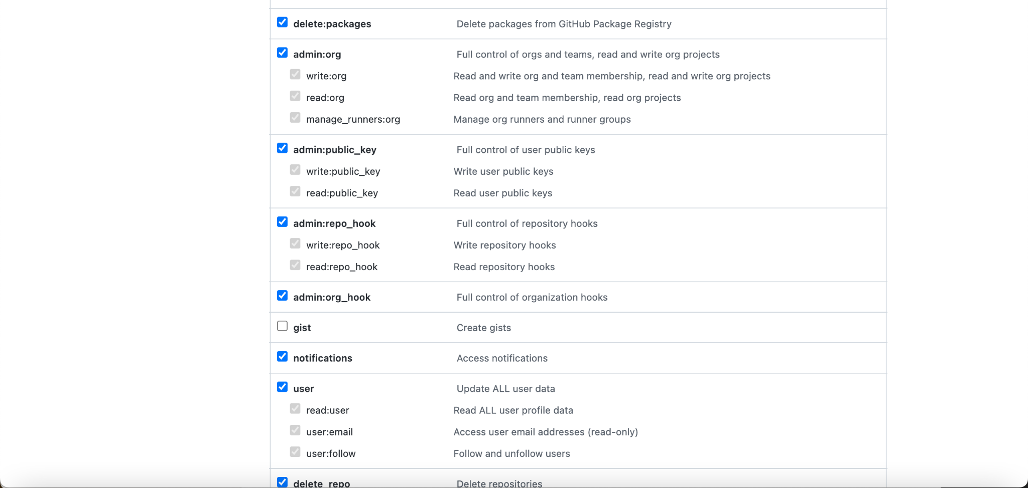

Click on Generate Token

\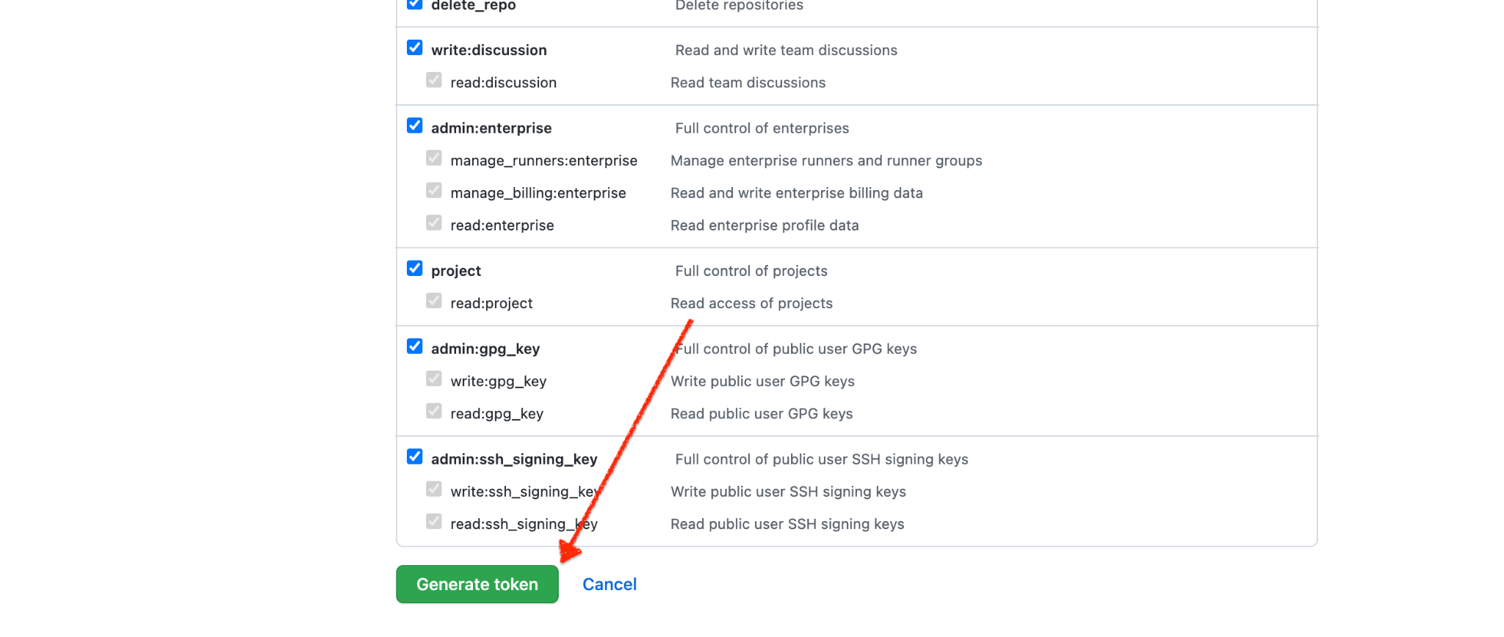

2-2   
Open Your personal Terminal and git clone the project to your personal directory

$ git clone https://github.com/FGCWORLDTECH/Lending.git

Username: YOUR_USERNAME

Password: YOUR_TOKEN

#This will allow you to create a feature branch and then switch to that branch

$git checkout -b feature

#create a file   
Touch cash

#initialize git

$ git init

$git add .

$git commit -m “first add file”  
  
#git push origin feature

Username: YOUR_USERNAME

Password: YOUR_TOKEN

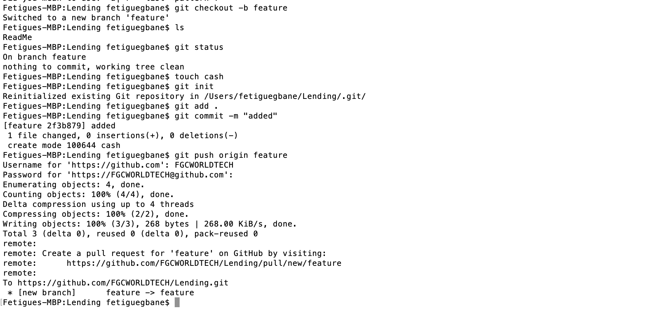

**We have created a feature branch ( which is the branch our developers are using for testing new feature states). As we have noticed the change ( new file created) is not in our main branch (master) but since we have not protected our main branch the developer could initiate a merge (Pull Request) to the main branch without any review. How to stop that ???**

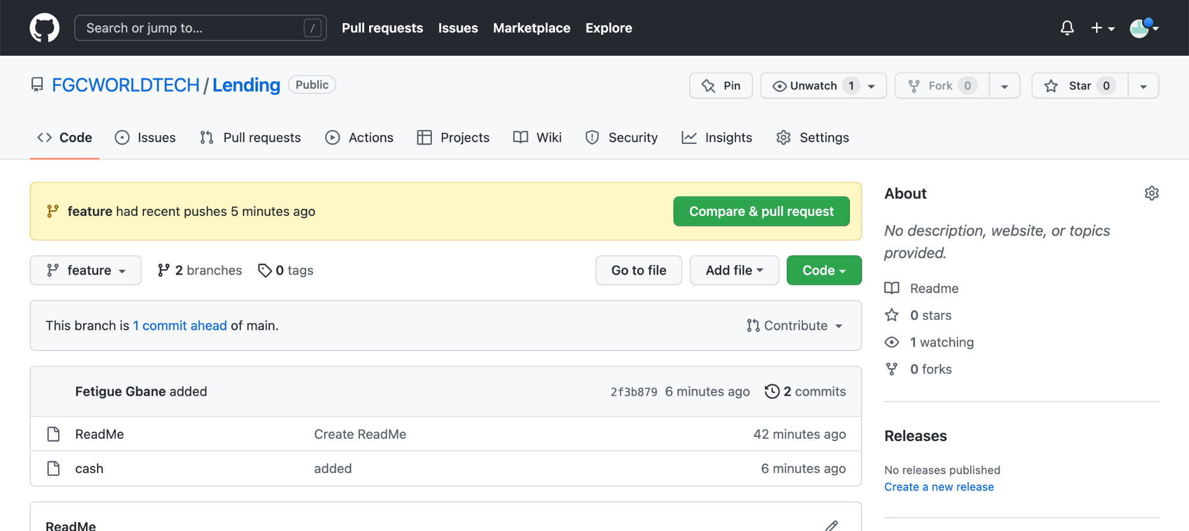

**3- Setting mandatory Code Review in Github**

**Pre-quisites**

* **Login to Enterprise github account**
* **Make sure the account has administrative privilege**

3-1 - create a file or a folder   
This could be perform through github GUI or command line   
 In step 2-2 we performed the step using the command line to create a file and push to a branch . We will use the GUI

3-2 - Click on add a file under a folder and a content to the file. In this we pretend to be the developer

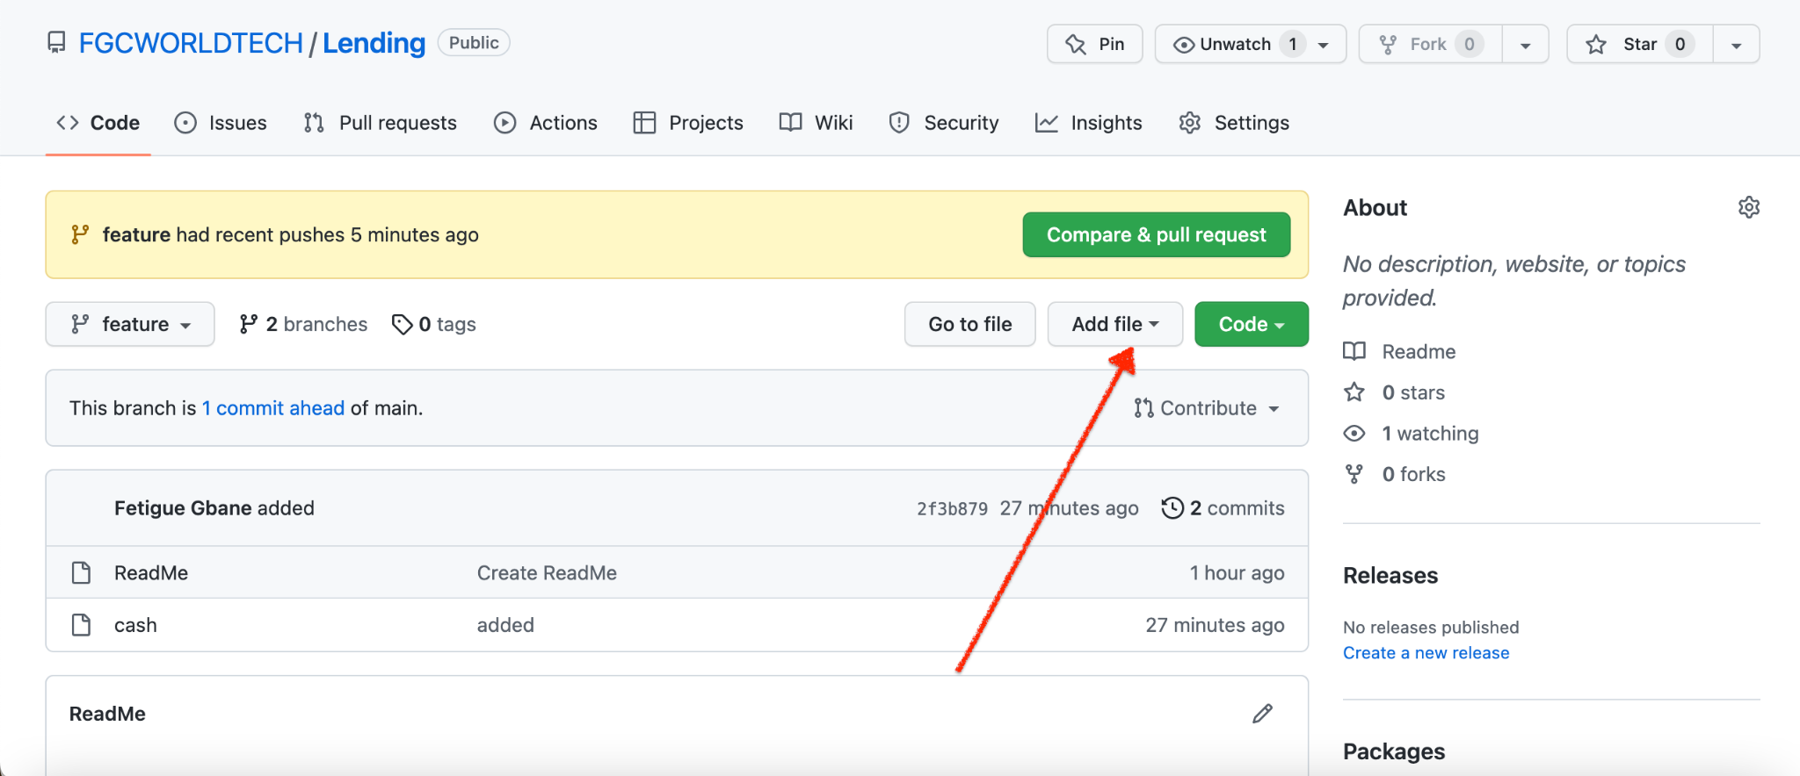

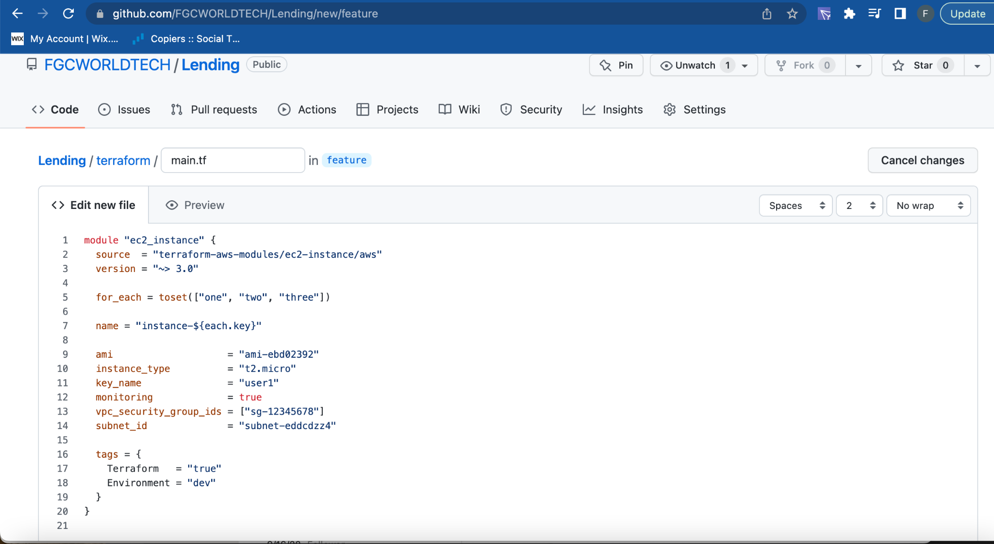

Add description and then commit to the feature branch

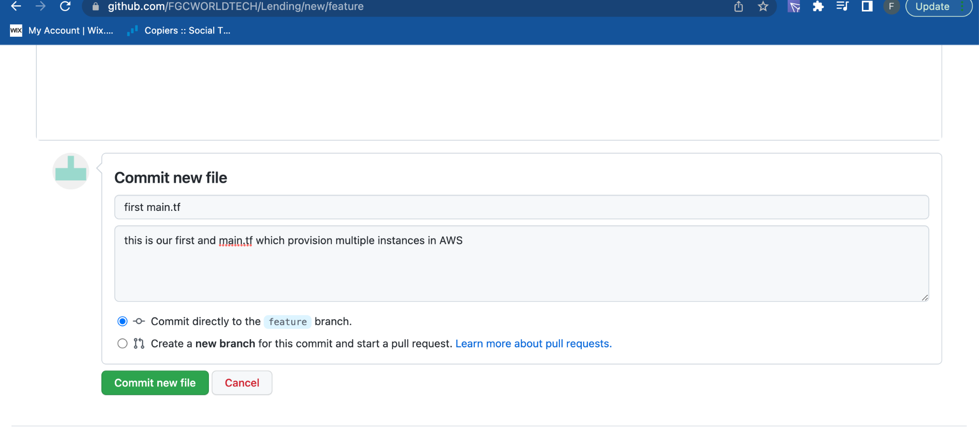

Key Point: what do we notice below ?   
1- We are still on the feature branch   
2- we have 2 commits ahead of main branch meaning main branch is below   
3- Some additional information regarding history of recent changes   
 “[feature](https://github.com/FGCWORLDTECH/Lending/tree/feature) had recent pushes less than a minute ago”

Finally, let’s protect our main branch from random PR without code reviews .   
Click on settings . If you don’t have settings it means your github account doesn’t have administrative privilege to perform the task.   
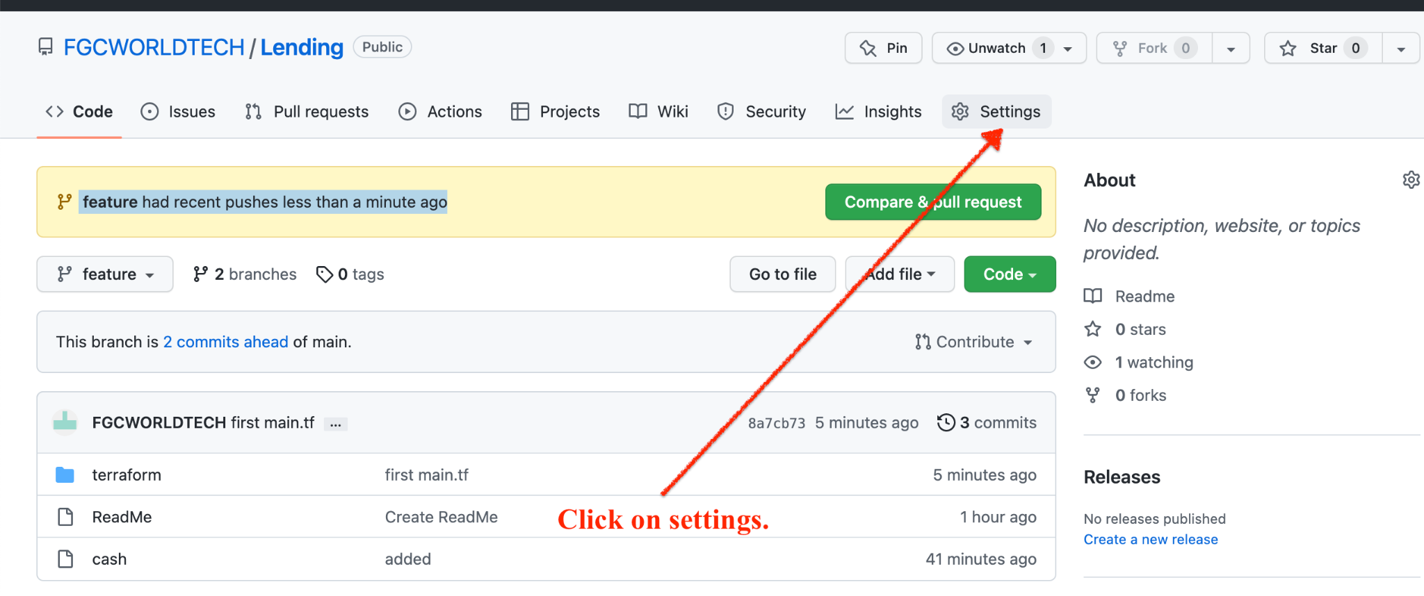

1- Click on branches

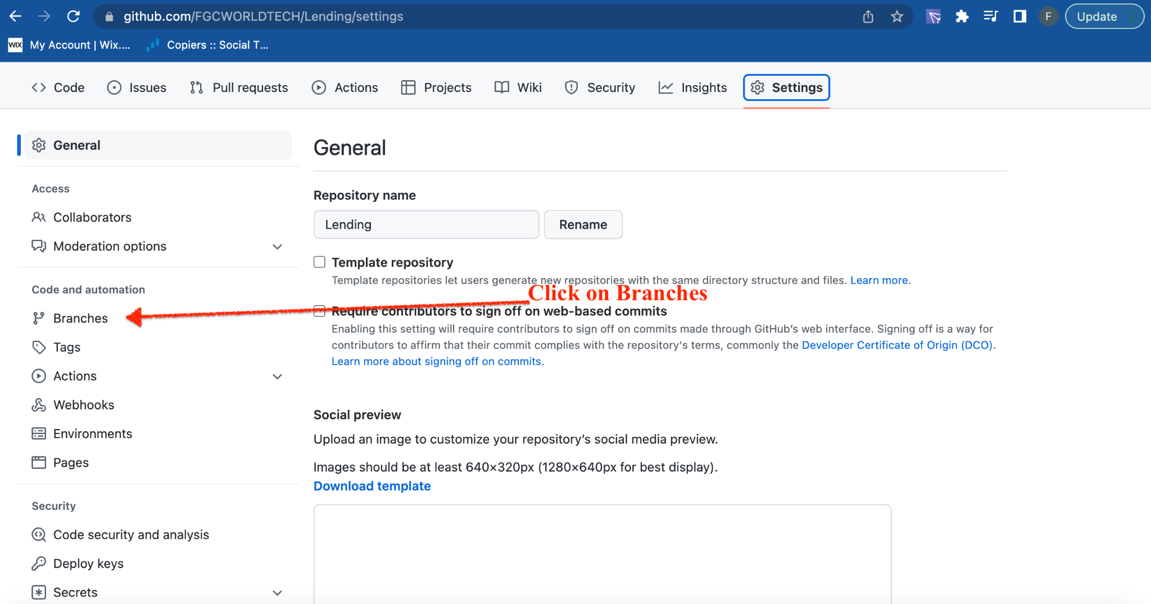

Click on add branch protection rule

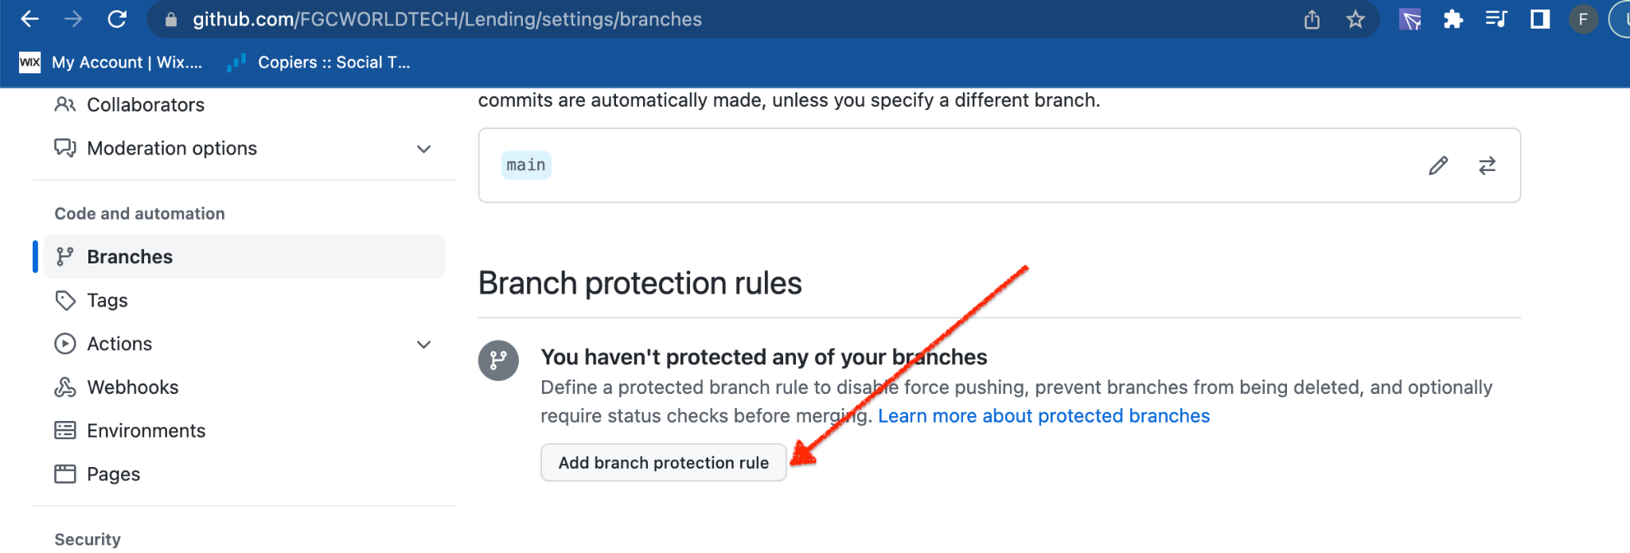

Branch names should be set up as “main” or master. Make sure everything else looks like the screenshots below. Also recommend 2 approvals before merging just to be extra careful. And then click on create

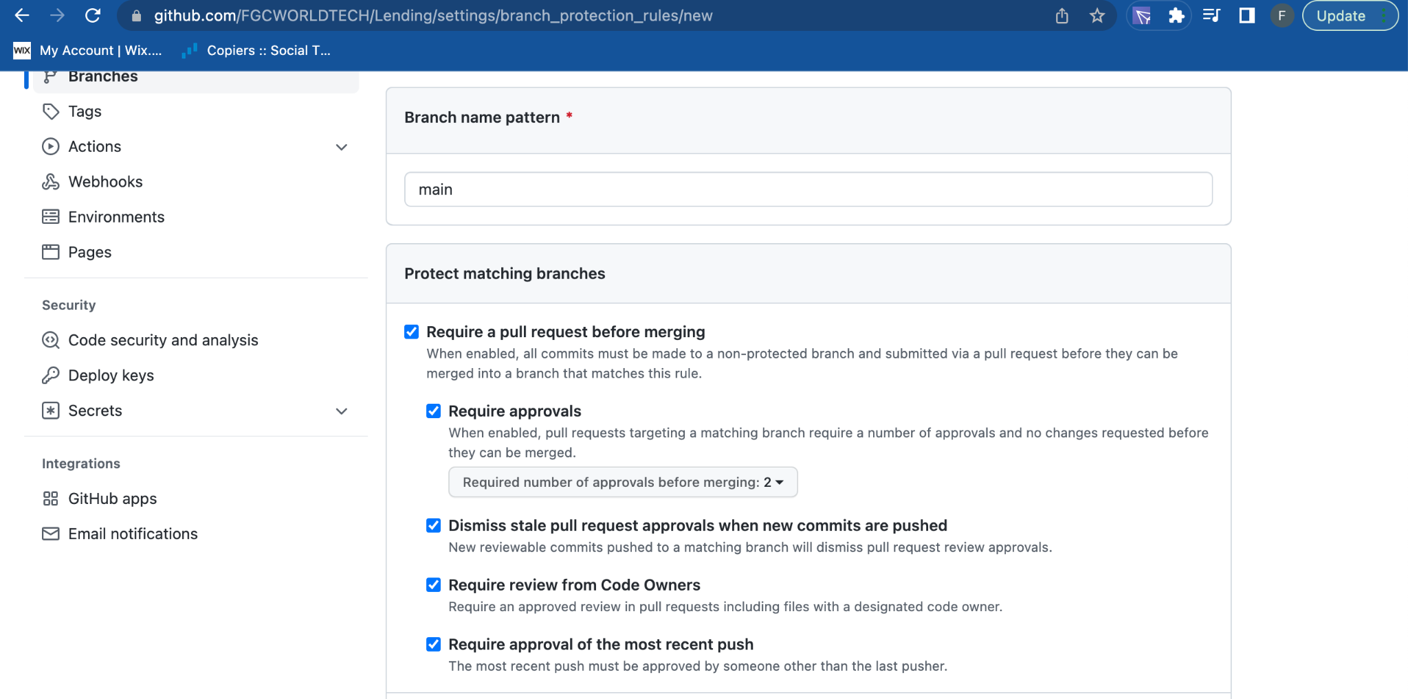

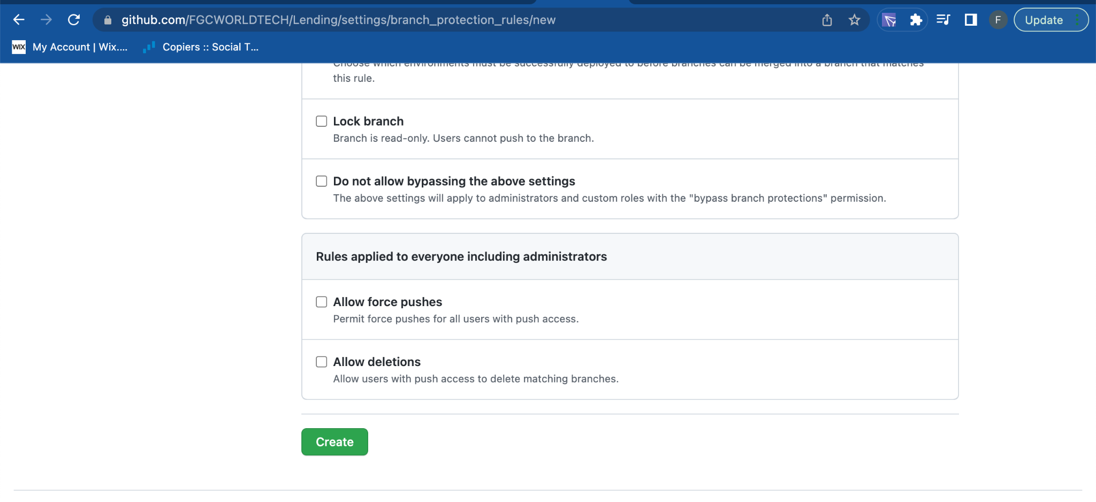

Make sure You see this “branch protection rule created” Now let’s test it   
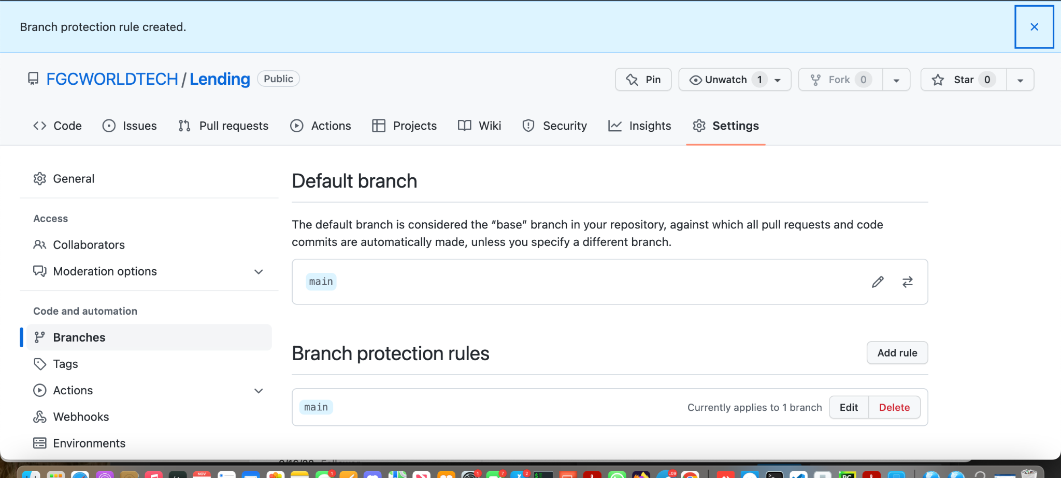

Now Let’s test our Pull request

4- Click on PR ( Pull Request from the feature branch)

* Create PR   
  Compare ( feature )   
  Base : main

And then click on create Pull request

